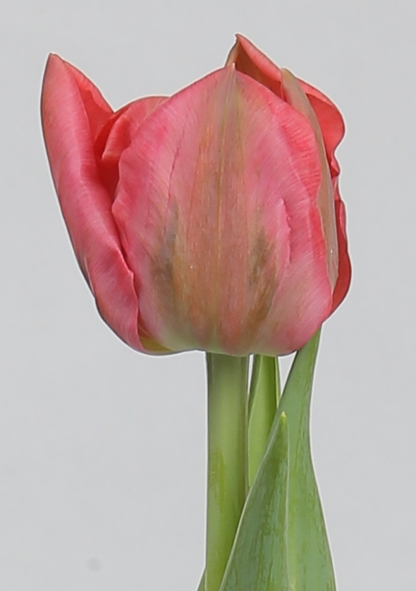
BARCELONA
Tulipa 12+ 550 psc
Cool: 5° Week: 43
Lot №: 1256



